**PATUAKHALI SCIENCE &**

**TECHNOLOGY UNIVERSITY**



**Course Code:** CIT-112 CSE 19th Batch 2021-2022

**Assignment No:** **Basic Code-07**

# Assignment Topic: Array and String + W3 resources- Array, String.

**SUBMITTED TO:**

Prof. Md Mahbubur Rahman

Faculty of Computer Science & Engineering

Department of Computer & Information Technology

**SUBMITTED BY:**

**Name: ABUL BASAR**

**ID:2102036; Registration No: 10163**

Faculty of Computer Science and Engineering

**Date of submission:18 August 2023**

**1. Write a program for fitting a straight line through a set of points (xi, yi),i=1,2,3….n. The straight line equation is: Y =mx+c and the values of m and c are given by: m=((n ∑(xi,yi))- (∑xi)(∑yi) )/( n(∑xi2)-(∑xi)2) c=1/n(∑yi -m(∑xi))**

**All summations are from 1 to n.**

**Ans:**

#include<stdio.h>

int main()

{

int n=10,i,j,x[10],y[10];

float m,c,total_x=0,total_y=0,total_xy=0,total_x2=0;

printf("Enter the value of x\n");

for(i=0;i<10;i++)

{

scanf("%d",&x[i]);

}

printf("Enter the value of y\n");

for(i=0;i<10;i++)

{

scanf("%d",&y[i]);

}

for(i=0;i<10;i++)

{

total_x+=x[i];

total_y+=y[i];

total_xy+=(x[i]*y[i]);

total_x2+=(x[i]*x[i]);

}

m=((n*total_xy-(total_x*total_y))/(n*total_x2-total_x2));

c=1/(n*(total_y-m*total_x));

printf("The equation of straight line is:\n");

printf("Y=%fX+%f\n",m,c);

return 0;

}

**Output:**

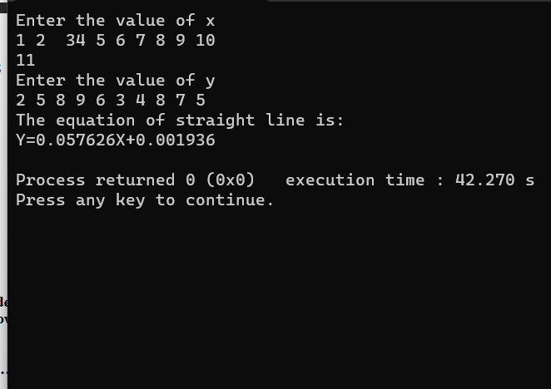

**2. The daily maximum temperature recorded in 10 cities during the month of January (for all 31 days) have been tabulated as follows: City**

**1 2 3 4 5 6 ……………………………10**

**Write a program to read the table elements into a two-dimensional array temperature, and to find the city and day corresponding to**

**a) the highest temperature**

**b) the lowest temperature**

**Ans:**

#include<stdio.h>

int main()

{

int Temp[2][2];

int i,j,City1,City2,MaxTemp,MinTemp;

printf("Enter temperature:--\n\n");

for(i=0;i<2;i++)

{

printf("For City %d ->\n",i+1);

for(j=0;j<2;j++)

{

printf("For Day %d ->",j+1);

scanf("%d",&Temp[i][j]);

}

}

printf("Temperature Matix :--- \n");

printf(" City \n ");

for(i=0;i<2;i++)

printf("%d ",i+1);

printf("\n Day\n");

for(i=0;i<2;i++)

{

printf(" %d ",i+1);

for(j=0;j<2;j++)

{

printf(" %d",Temp[i][j]);

}

printf("\n");

}

MinTemp=MaxTemp=Temp[0][0];

City1=0;

City2=0;

for(i=0;i<2;i++)

{

for(j=0;j<2;j++)

{

if(MaxTemp<Temp[i][j])

{

MaxTemp=Temp[i][j];

City1=j+1;

}

if(MinTemp>Temp[i][j])

{

MinTemp=Temp[i][j];

City2=j+1;

}

}

}

printf("\n\nHighest Temperature of City %d is %d\n",City1,MaxTemp);

printf("Lowest Temperature of City %d is %d\n",City2,MinTemp);

return 0;

}

**Output:**

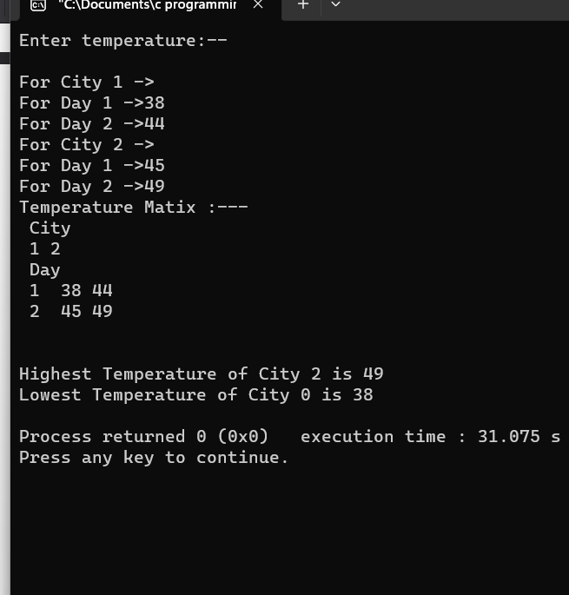

**3. An election is contested by 5 candidates. The candidate are numbered are 1 to 5 and the voting is done by marking the candidate number on the ballot paper. Write a program to read the ballots and count the votes cast for each candidate using an array variable count. In case, a number, read is outside the range 1 to 5,the ballot should be considered as a ‘spoilt ballot’ and the program should also count the number of spoilt ballots**

**Ans:**

#include<stdio.h>

int main()

{

int i,vote[5],c1=0,c2=0,c3=0,c4=0,c5=0,count=0,count_sp=0;

printf("Enter your votes for 5 candidates:");

for(i=1;i<=5;i++)

{

scanf("%d",&vote[i]);

}

for(i=1;i<=5;i++)

{

if(vote[i]==1)

c1+=1;

if(vote[i]==2)

c2=c2+1;

if(vote[i]==3)

c3=c3+1;

if(vote[i]==4)

c4=c4+1;

if(vote[i]==5)

c5=c5+1;

}

printf(" votes to candidate1=%d",c1);

printf(" \nvotes to candidate2=%d",c2);

printf("\n votes to candidate3=%d",c3);

printf(" \nvotes to candidate4=%d",c4);

printf(" \nvotes to candidate5=%d",c5);

for(i=1;i<=5;i++)

{

if(vote[i]<=5)

count=count+1;

else

count_sp=count_sp+1;

}

printf(" The number of valid votes is:%d",count);

printf(" \nThe number of spoilt votes is:%d",count_sp);

return 0;

}

**Output:**

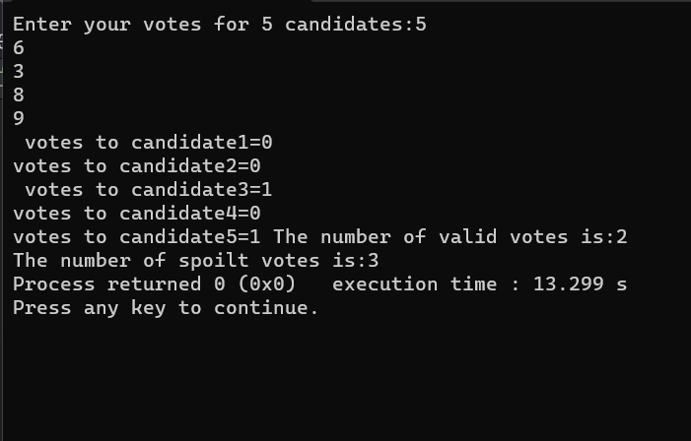

**4. The following set of numbers is popularly known as Pascal’s triangle.**

**Ans:**

#include <stdio.h>

int main() {

int rows, coef = 1, space, i, j;

printf("Enter the number of rows: ");

scanf("%d", &rows);

for (i = 0; i < rows; i++) {

for (space = 1; space <= rows - i; space++)

printf(" ");

for (j = 0; j <= i; j++) {

if (j == 0 || i == 0)

coef = 1;

else

coef = coef * (i - j + 1) / j;

printf("%4d", coef);

}

printf("\n");

}

return 0;

}

**Output:**

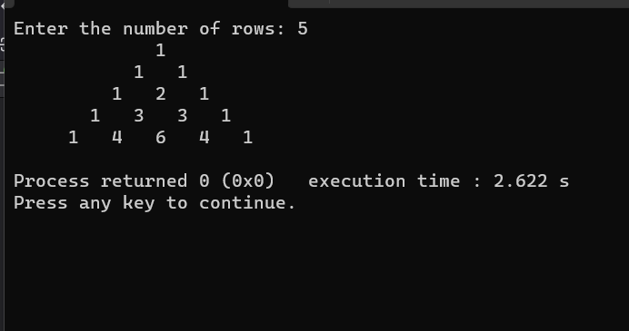

**5. The annual examination results of 10 students are tabulated as follows:**

**Roll No. Subject1 Subject2 Subject3**

.

.

.

**.____________________________________________________________________**

**Write a program to read the data and determine the following:**

**(a) Total marks obtained by each student.**

**(b) The highest marks in each subject and the Roll No. of the student who**

**secured it.**

**(c) The student who obtained the highest total marks.**

**Ans:**

#include<stdio.h>

#define MAX 10

int main()

{

int i,roll=0,m1,m2,m3,sub1[10],sub2[10],sub3[10],max,max1,max2,max3,roll1=0,roll2=0,roll3=0;

int t_sub1=0,t_sub2=0,t_sub3=0,t[10];

printf("Enter the marks for subject 1 of all students:\n");

for(i=0;i<MAX;i++){

scanf("%d",&sub1[i]);

t_sub1+=sub1[i];

}

printf("Enter the marks for subject 2 of all students:\n");

for(i=0;i<MAX;i++){

scanf("%d",&sub2[i]);

t_sub2+=sub2[i];

}

printf("Enter the marks for subject 3 of all students:\n");

for(i=0;i<MAX;i++){

scanf("%d",&sub3[i]);

t_sub3+=sub3[i];

t[i]=sub1[i]+sub2[i]+sub3[i];

}

max1=sub1[0];

max2=sub2[0];

max3=sub3[0];

max=t[0];

for(i=0;i<MAX;i++)

{

printf("The total marks obtained by the student%d is =%d\n",i+1,t[i]);

}

for(i=0;i<MAX;i++)

{

if(max1<sub1[i])

{

max1=sub1[i];

roll1=i+1;

}

if(max2<sub2[i])

{

max2=sub2[i];

roll2=i+1;

}

if(max3<sub3[i])

{

max3=sub3[i];

roll3=i+1;

}

if(max<t[i])

{

max=t[i];

roll=i+1;

}

}

printf("\nThe highest marks in subject1 is %d and the roll number is %d",max1,roll1);

printf("\nThe highest marks in subject2 is %d and the roll number is %d",max2,roll2);

printf("\nThe highest marks in subject3 is %d and the roll number is %d",max3,roll3);

printf("\n The highest total marks is %d and the roll number is %d ",max,roll);

return 0;

}

**Output:**

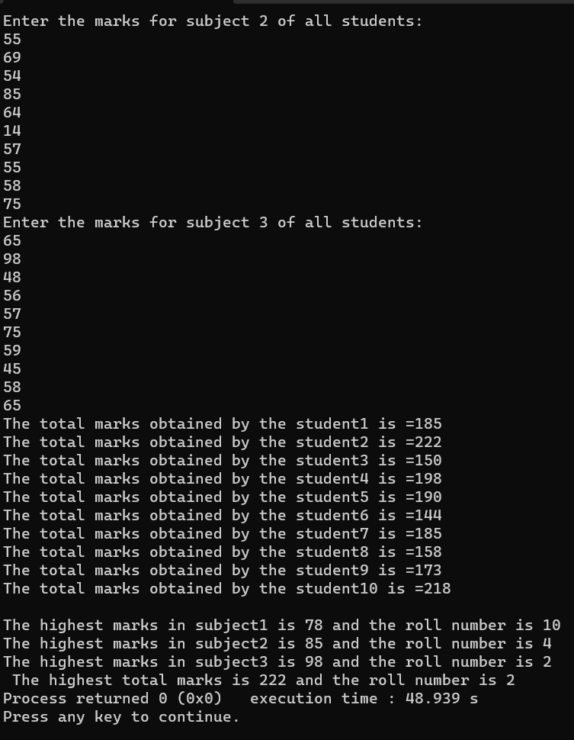

**6. Given are one dimensional arrays A and B which are sorted in ascending**

**order. Write a program to merge them into a single sorted array C that contains**

**every item form array A and B, in ascending order.**

**Ans:**

#include<stdio.h>

#define MAX 50

void main()

{

int a[MAX],b[MAX],c[MAX];

int i,ax,bx,cx,n,m,mn;

ax=bx=cx=0;

printf("Enter no. of elements of array : ");

scanf("%d %d",&n,&m);

printf("Enter elements of first array :\n");

for(i=0;i<n;i++)

scanf("%d",&a[i]);

printf("Enter elements of Second array :");

for(i=0;i<m;i++)

scanf("%d",&b[i]);

mn=m+n;

while(ax<n && bx<m)

{

if(a[ax]<b[bx])

{

c[cx]=a[ax];

ax++;

}

else

{

c[cx]=b[bx];

bx++;

}

cx++;

}

if(ax==n)

{

while(bx<m)

{

c[cx]=b[bx];

bx++;

cx++;

}

}

else

{

while(ax<n)

{

c[cx]=a[ax];

ax++;

cx++;

}

}

printf("the sorted array is : \n");

for(i=0;i<mn;i++)

printf("%d ",c[i]);

return 0;

}

Output:

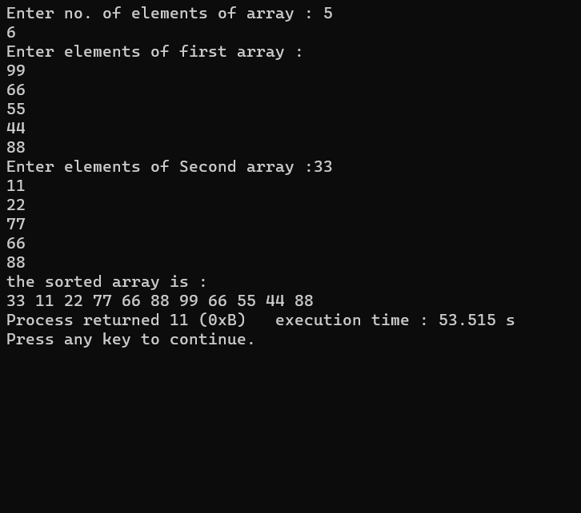

7. Write a program that fills a five-by-five as follows:

• Upper left triangle with +1s

• Lower right triangle with -1s

• Right to left diagonal with zeros

Display the contents of the matrix using not more than two printf statements.

Ans:

#include<stdio.h>

int main()

{

int A[5][5];

int a,i,k,j;

a=3;

for(i=0;i<=3;i++)

{

for(j=0;j<=a;j++)

{

A[i][j]=+1;

}

a--;

}

j=4;

for(i=0;i<=4;i++)

{

A[i][j]=0;

j--;

}

a=4;

for(i=1;i<=4;i++)

{

for(j=4;j>=a;j--)

{

A[i][j]=-1;

}

a--;

}

printf("Array is:--\n\n");

for(i=0;i<=4;i++)

{

for(j=0;j<=4;j++)

printf(" %d ",A[i][j]);

printf("\n");

}

return 0;

}

**Output:**

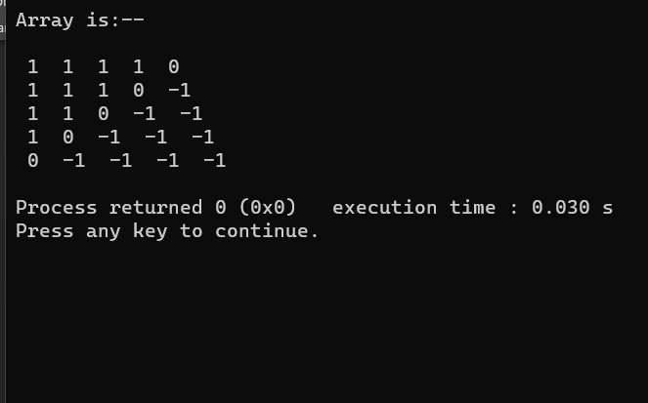

**8. Write a program that will read the values of elements of A and B and produce the product matrix C.**

**Ans:**

#include<stdio.h>

int main()

{

int i,j,a[3][3],b[3][3],c[3][3],sum,k;

printf("Enter 1ST array element:\n");

for(i=0;i<3;i++){

for(j=0;j<3;j++){

scanf("%d",&a[i][j]);

}

}

printf("Enter 2ND array element:\n");

for(i=0;i<3;i++){

for(j=0;j<3;j++){

scanf("%d",&b[i][j]);

}

}

printf("THIS 1ST MARTIX IS:\n");

for(i=0;i<3;i++){

for(j=0;j<3;j++){

printf("%d\t",a[i][j]);

}

printf("\n");

}

printf("\n");

printf("THIS 2ND MARTIX IS:\n");

for(i=0;i<3;i++){

for(j=0;j<3;j++){

printf("%d\t",b[i][j]);

}

printf("\n");

}

printf("\n");

for(i=0;i<3;i++){

for(j=0;j<3;j++){

sum=0;

for(k=0;k<3;k++){

sum=sum+(a[i][k]*b[k][j]);

}

c[i][j]=sum;

}

}

printf("THIS MULTIPLICATION MARTIX IS:\n");

for(i=0;i<3;i++){

for(j=0;j<3;j++){

printf("%d\t",c[i][j]);

}

printf("\n");

}

return 0;

}

**Output:**

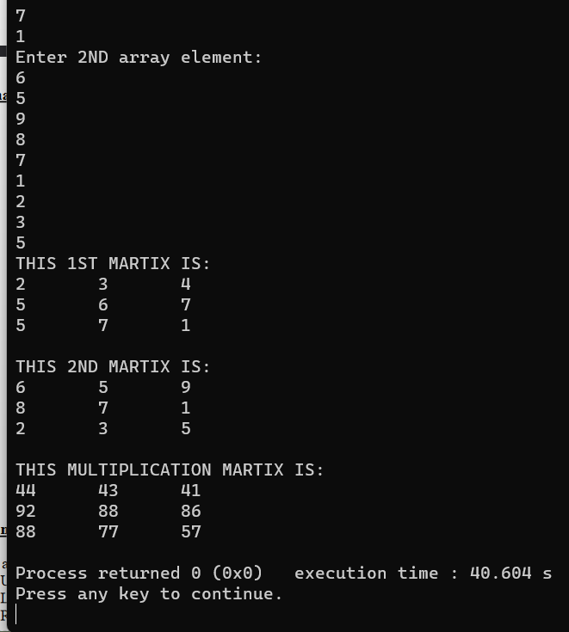

**9. Write a program to implement selection sort.**

**Ans:**

#include<stdio.h>

int main()

{

int Str[10];

int i,Beg,End,Mid,Item;

Beg=0;

End=9;

Mid=(Beg+End)/2;

printf("Enetr Any Sorted Array:--\n");

for(i=0;i<10;i++)

scanf("%d",&Str[i]);

printf("Enter Item Which U want to Search:--\n");

scanf("%d",&Item);

while((Item!=Str[Mid])&&(Beg<=End))

{

if(Item<Str[Mid])

End=Mid-1;

else

Beg=Mid+1;

Mid=(Beg+End)/2;

}

if(Beg>End)

printf("Item Not Found\n");

else

printf("%d Found At Index %d\n",Item,Mid);

return 0;

}

**Output:**

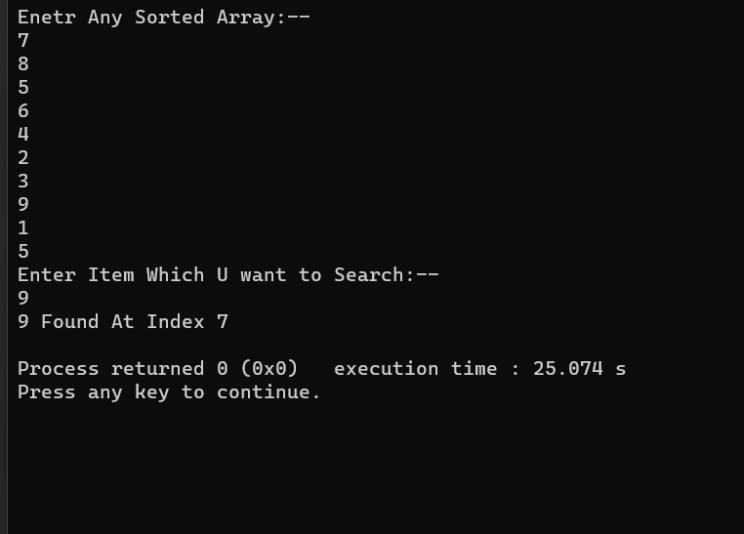

**10. Write a program that will count the number occurrences of a specified character in a given line of text.**

**Ans:**

#include<stdio.h>

int main()

{

char Str[50],CheckChar;

int i,Count,Len;

Count=0;

printf("Enter a String:---\n");

scanf("%[^\n]s",&Str);

Len=strlen(Str);

fflush(stdin);

printf("Enter a charatcer:--\n");

scanf("%c",&CheckChar);

for(i=0;i<=Len;i++)

if(CheckChar==Str[i])

Count=Count+1;

printf("Number of occurences of %c is %d",CheckChar,Count);

return 0;

}

**Output:**

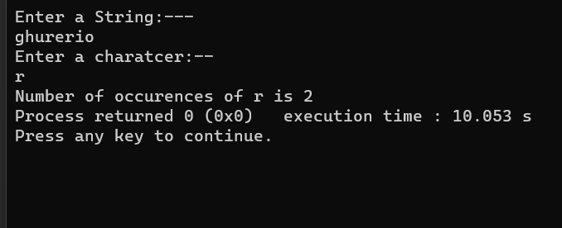

**11. Write a C program to compute the sum of elements of two one-dimensional arrays and store the corresponding result in another array.**

**Ans:**

#include<stdio.h>

int main()

{

int i,j,a[3][5],s=0;

printf("Enter the elements of two-dimensional arrays:\n ");

for(i=0;i<3;i++)

{

for(j=0;j<5;j++)

{

scanf("%d",&a[i][j]);

s+=a[i][j];

}

}

printf("%d\n",s);

return 0;

}

**Output:**

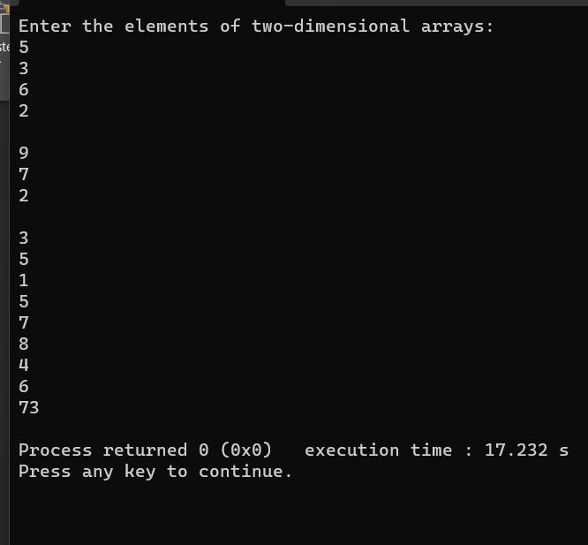

**12. Write a program, which reads your name from the keyboard and outputs a list of ASCII codes, which represent your name.**

**Ans:**

#include<stdio.h>

#include<string.h>

int main()

{

char v,s[50];

int i;

printf("Enter your name:\n");

gets(s);

printf("Equivalent list of ASCII codes:\n");

for(i=0;s[i]!='\0';i++)

{

printf("%c=%d\n",s[i],'s[i]');

}

return 0;

}

**Output:**

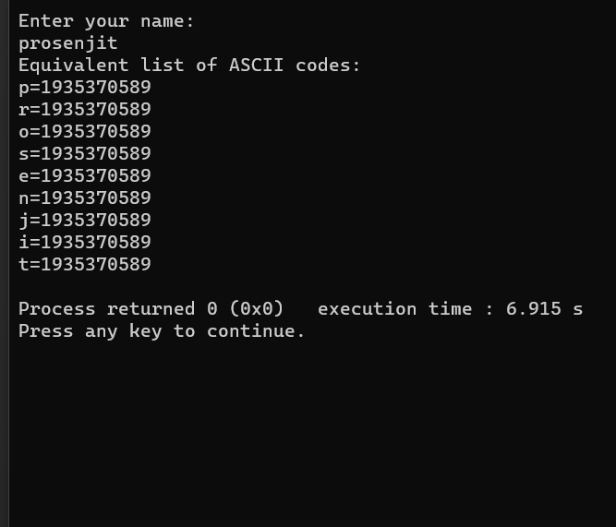

**13. Write a program to read to strings and compare them using the function strcmp() and print a mesaage that the first string is equal, less or greater than the second one.**

**Ans:**

#include<stdio.h>

#define MAX 50

int main()

{

char Str1[MAX],Str2[MAX];

printf("Enter First String:--\n");

gets(Str1);

printf("Enter Second String:--\n");

gets(Str2);

if(strcmp(Str1,Str2)==0)

printf("\nBoth Strings are Equal\n");

else if(strcmp(Str1,Str2)<0)

printf("\nFirst String is Less Than\n");

else

printf("\nFirst String is Greater Than\n");

return 0;

}

**Output:**

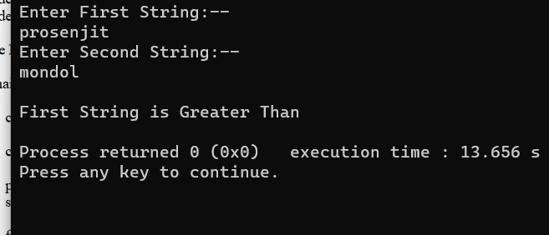

**14. Write a program that will copy m consecutive characters from a string s1 beginning at position n into another string s2**

**Ans:**

#include<stdio.h>

#define MAX 50

int main()

{

char Str1[MAX],Str2[MAX];

int i,m,n,j;

printf("Enter A String:--\n");

scanf("%[^\n]s",Str1);

printf("\nEnter Number of Characters Which U Wnat to Copy-->\n");

scanf("%d",&m);

printf("\nEnter Beginnig Index from Which U Want to Copy-->\n");

scanf("%d",&n);

for(i=n-1,j=0;i<m+n;i++,j++)

{

Str2[j]=Str1[i];

}

Str2[m]='\0';

printf("\n\nCopied String is--> %s \n\n",Str2);

return 0;

}

**output**

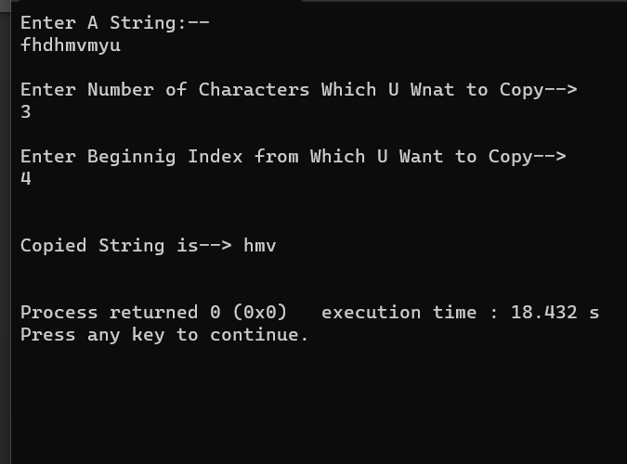

**15. Given a string char str[ ] =”123456789”; Write a program that displays the following:**

1

**2 3 2**

**3 4 5 4 3**

**4 5 6 7 6 5 4**

**5 6 7 8 9 8 7 6 5**

**Ans:**

#include<stdio.h>

#include<string.h>

int main()

{

char str[]="123456789";

int i,j,k,v,m=0;

for(i=0;i<5;i++)

{

for(j=4;j>i;j--)

printf(" ");

for(k=0,v=i;k<=i;k++,v++)

printf("%c",str[v]);

v=v-2;

for(m=0;m<i;m++,v--)

printf("%c",str[v]);

printf("\n");

}

}

**Output:**

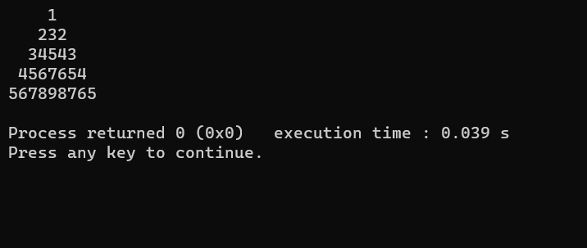

**17. Write a C program to replace all the white spaces in a string with double white spaces.**

**Ans:**

#include <stdio.h>

int main()

{

char str[100];

int i, j = 0;

printf("Enter String to Remove White Spaces = ");

gets(str);

printf("String before Removing Empty Spaces = %s\n", str);

for(i = 0; str[i] != '\0'; i++)

{

str[i] = str[i + j];

if(str[i] == ' ' || str[i] == '\t')

{

j++;

i--;

}

}

printf("String after Removing Empty Spaces = %s\n", str);

return 0;

}

**Output:**

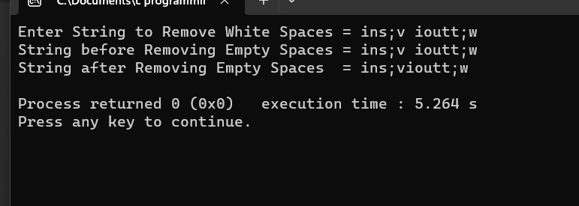

**19. Write a C program to enter multiple strings and display them in lexicographical order.**

**Ans:**

#include<stdio.h>

#include<string.h>

int main()

{

char str[10][50],temp[50];

int i,j;

printf("Enter 10 Words:\n");

for(i=0;i<10;i++)

scanf("%s[^\n]",str[i]);

for(i=0;i<9;i++)

{

for(j=i+1;j<10;j++)

{

if(strcmp(str[i],str[j])>0)

{

strcpy(temp,str[i]);

strcpy(str[i],str[j]);

strcpy(str[j],temp);

}

}

}

printf("\nIn lexicographical order: \n");

for(i=0;i<10;i++)

puts(str[i]);

return 0;

}

**Output:**

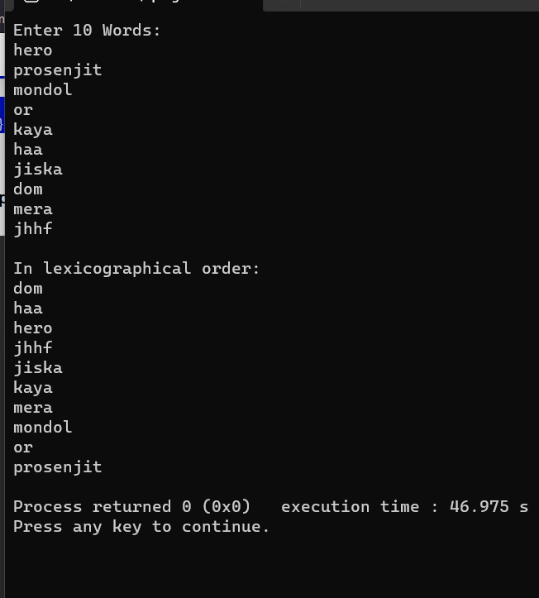

**20. Write a C program to concatenate two strings**

**without using any string function**.

**Ans:**

#include<stdio.h>

int main()

{

char str1[25],str2[25];

int i=0,j=0;

printf("\nEnter First String:");

gets(str1);

printf("\nEnter Second String:");

gets(str2);

while(str1[i]!='\0')

i++;

while(str2[j]!='\0')

{

str1[i]=str2[j];

j++;

i++;

}

str1[i]='\0';

printf("\nConcatenated String is %s",str1);

return 0;

}

**Output:**

